1. A belt

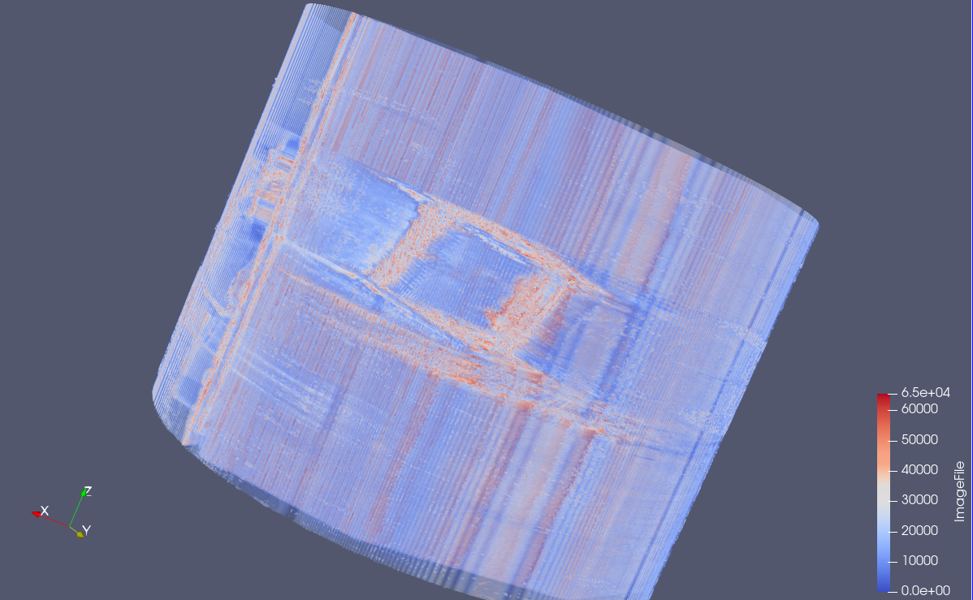

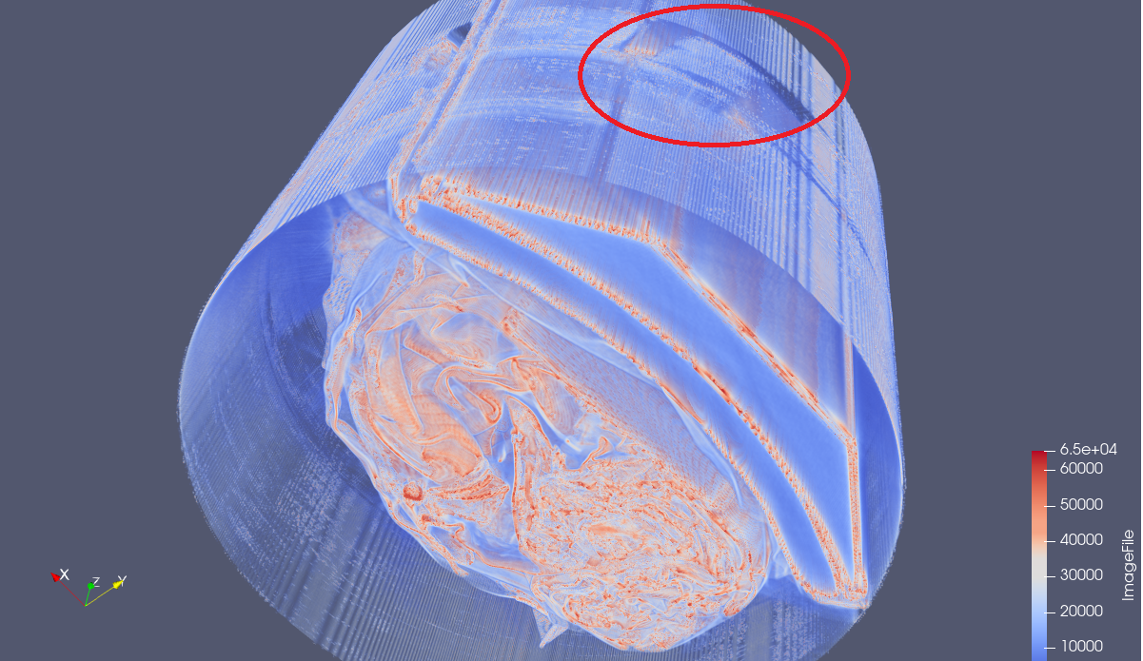

On the outermost place, at the folder’s side, tide up the whole backpack (with some paper, I guess?)

1. Some folders

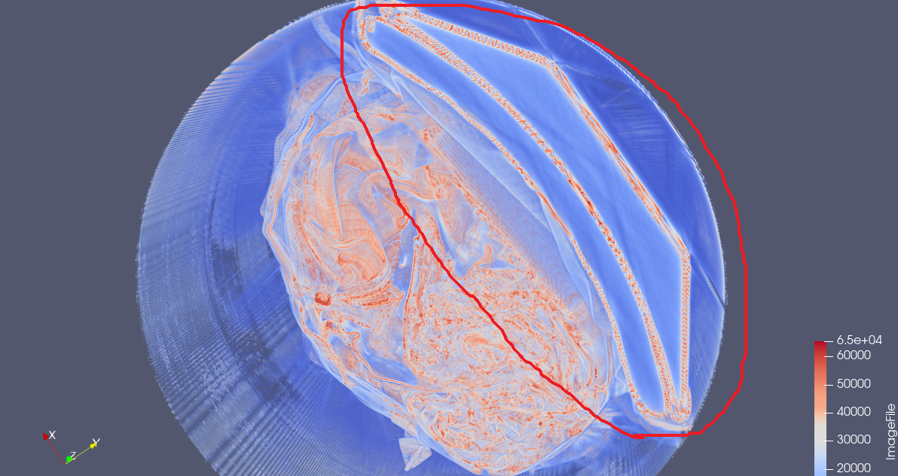

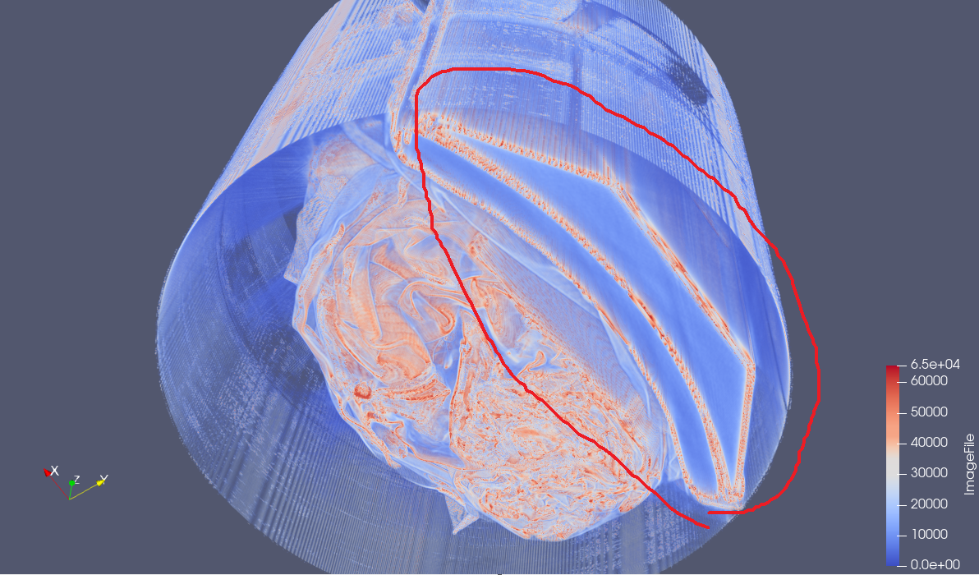

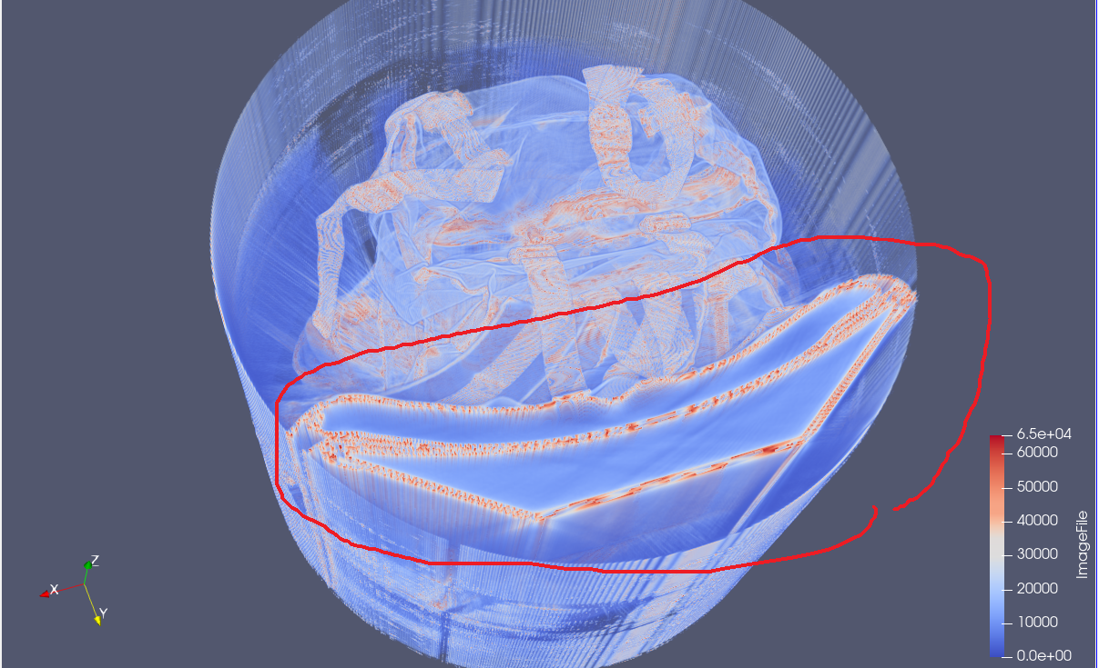

A long, strange, multi-layer thing, filled a quarter of the backpack, beside the belt.

1. A purse

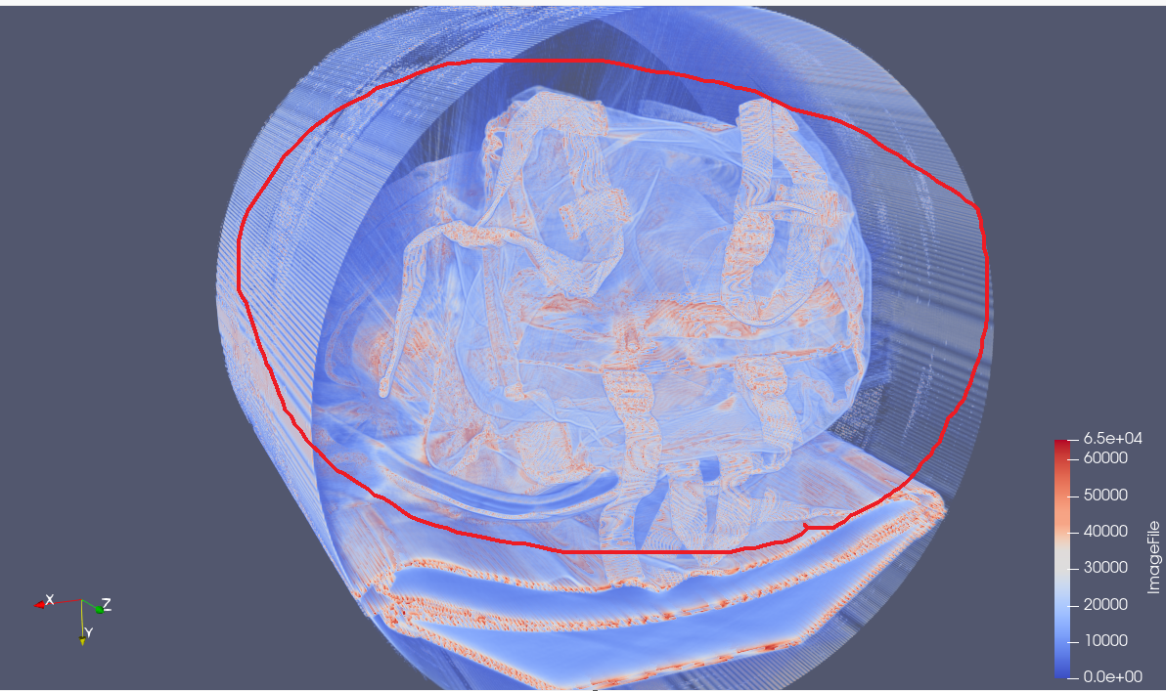

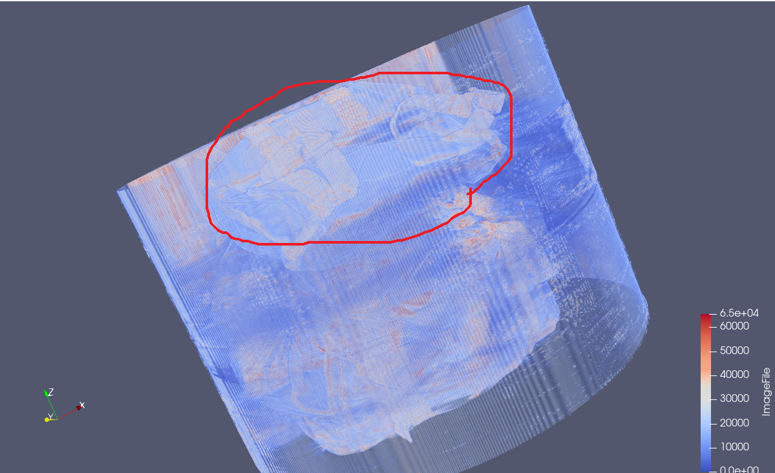

Flat, 3 handles, must be a nice-looking female purse or small pack that is easy-carried, which can contain your wallet, phones and keys.

1. A travelling backpack

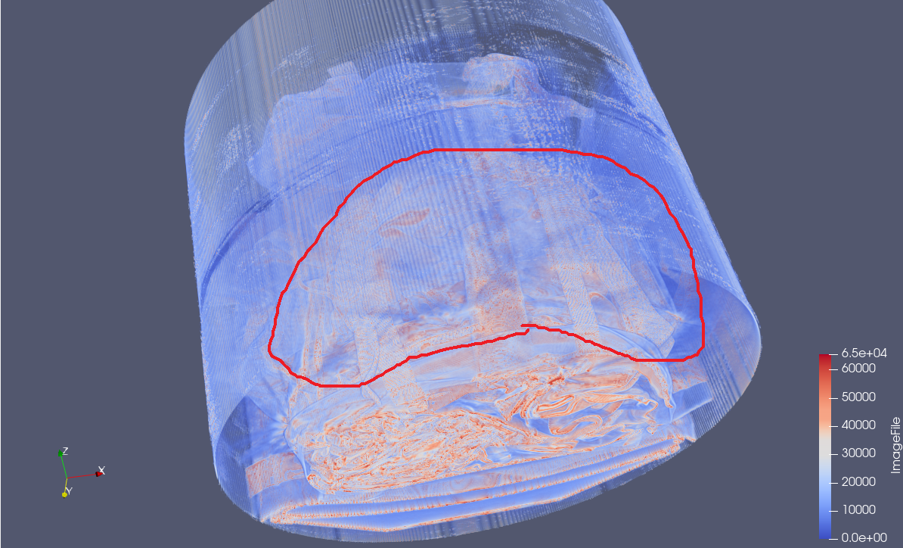

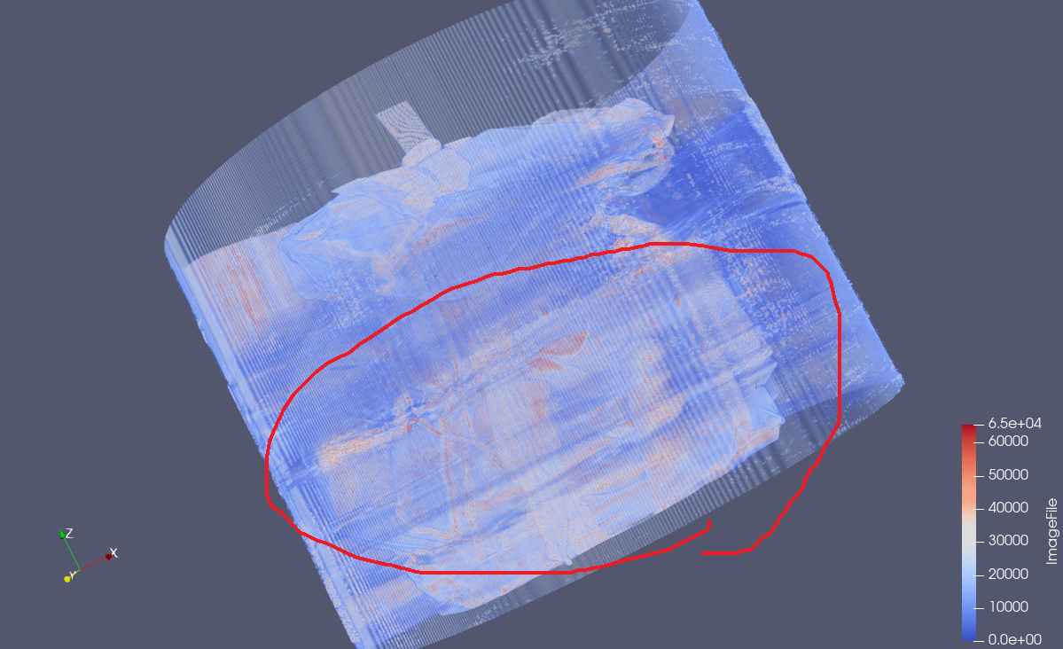

Under the purse, a larger backpack is there, full of things.

1. A bag of noodles

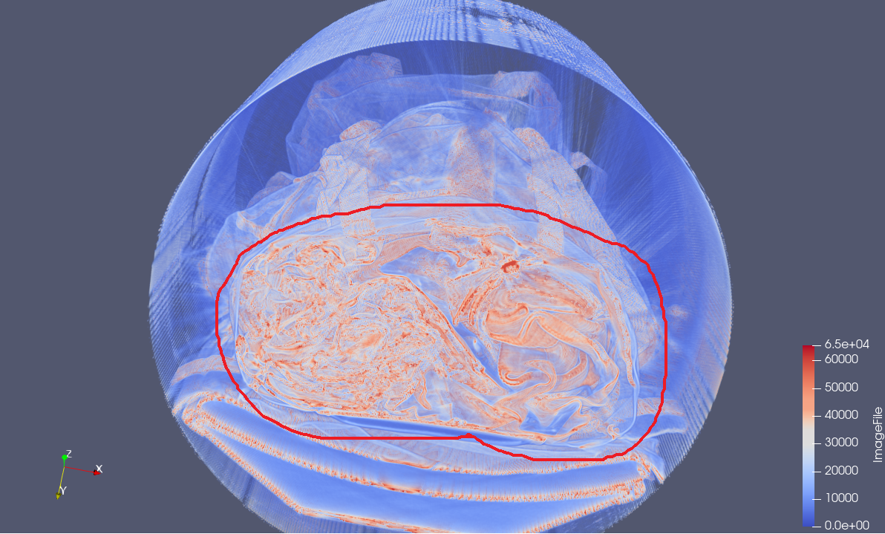

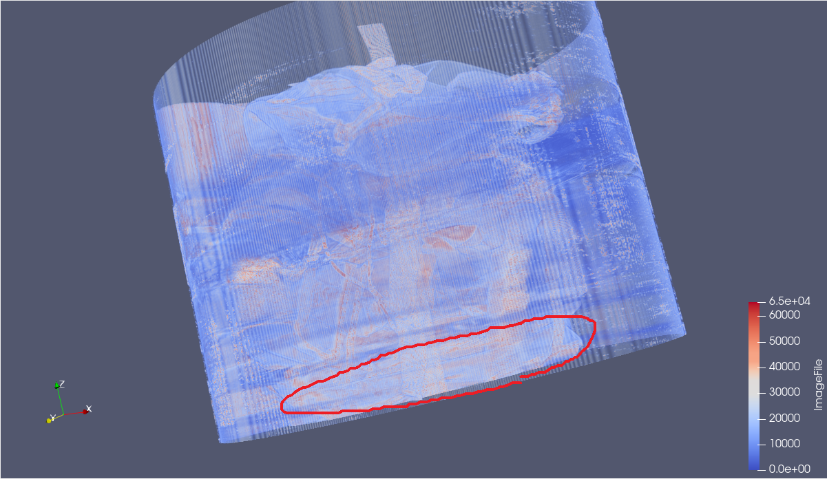 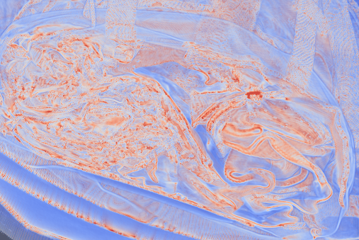

At the bottom of the bag, with lots of puckering and kept some space from the thin plastic, I guess is a plastic bag of noodles, since it looks so messy, thin and long.

The owner must be hungry.

1. Water bottle

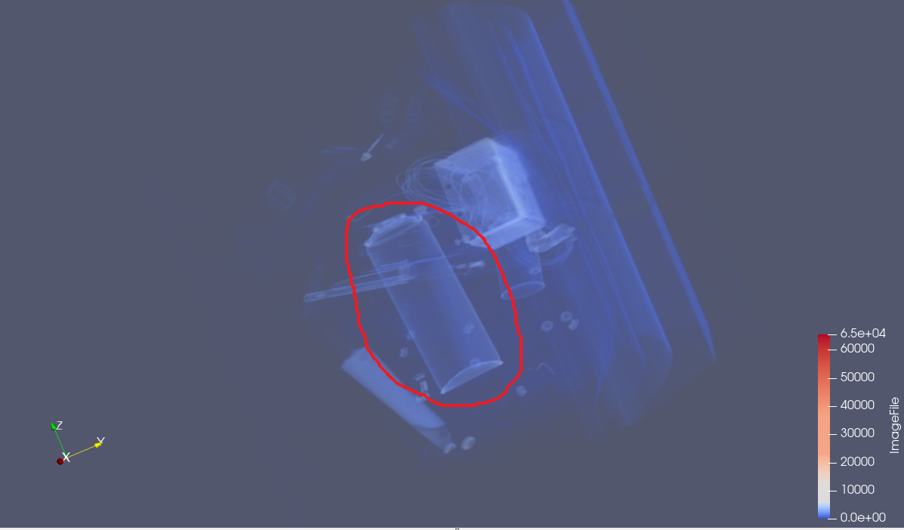

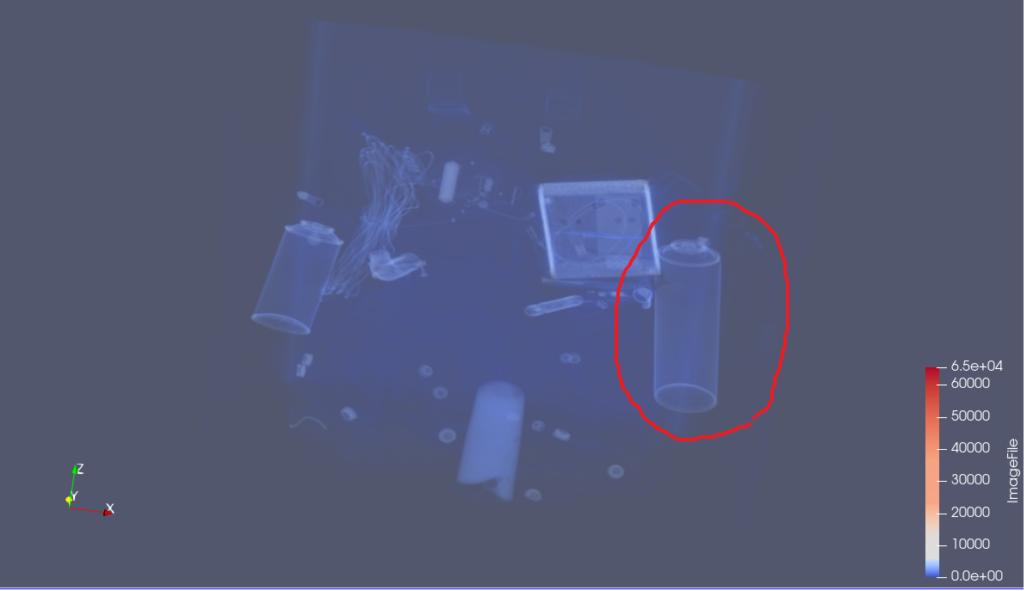

Nothing to say, it is just a bottle.

1. A Smoke Grenade

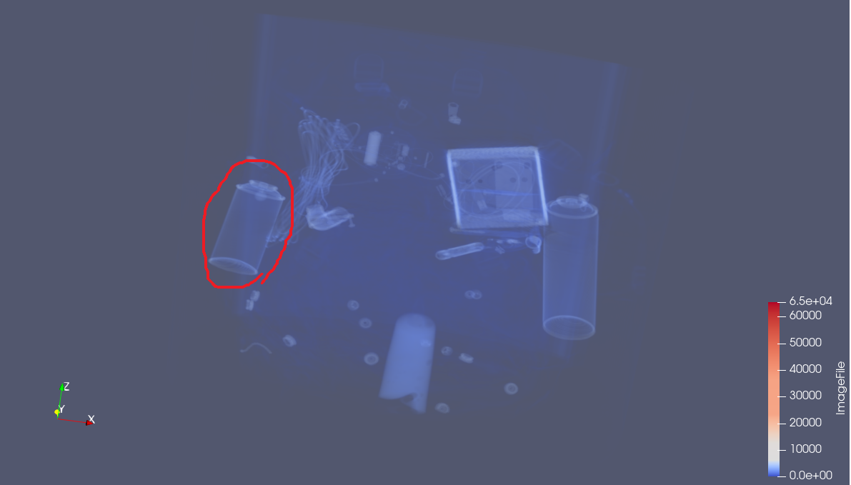

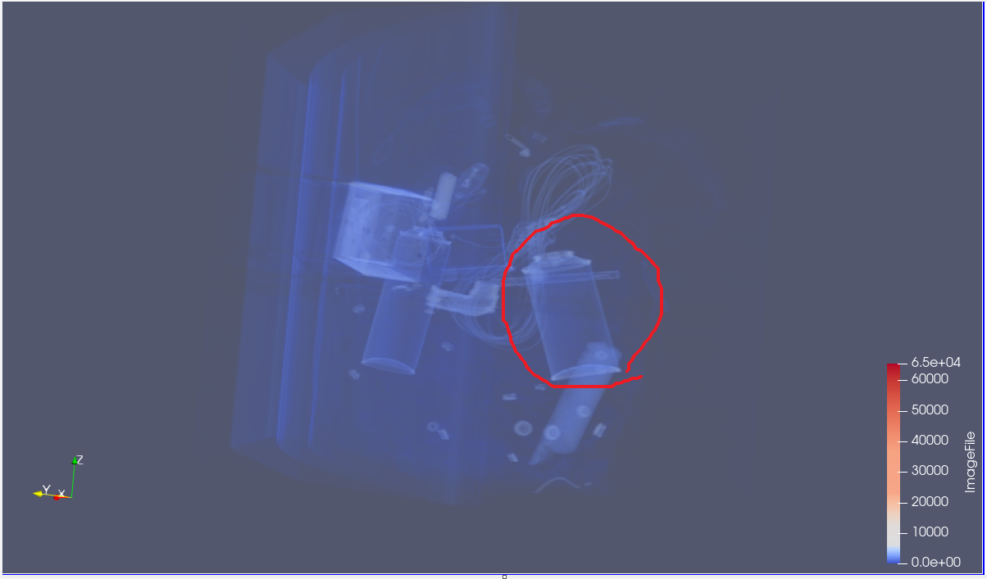

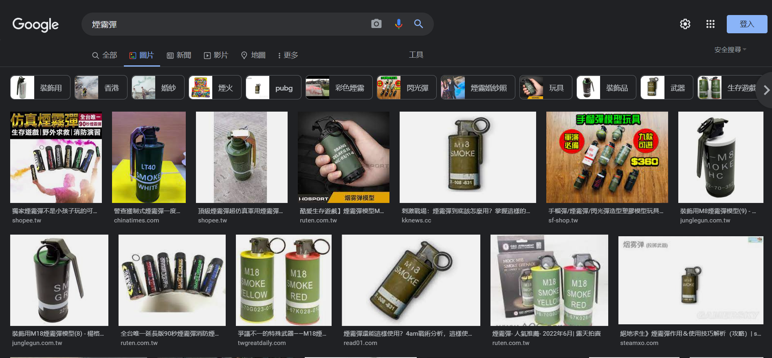

At first, I thought it was just another bottle. But later on, I realized that its size is too short, looking really weird… I mean, who would use that size of bottle? Its shape is just like a smoke grenade. And these things feels like being kept for reasons, I guess that’s why.

1. A bundle of copper wire

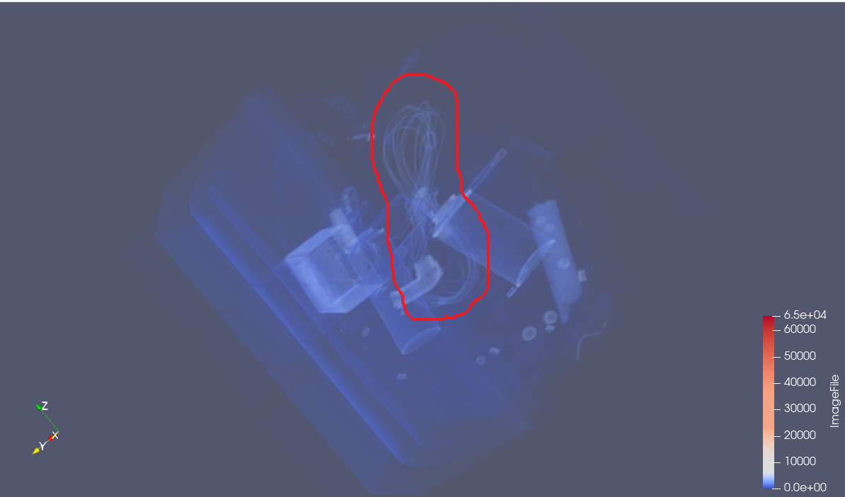

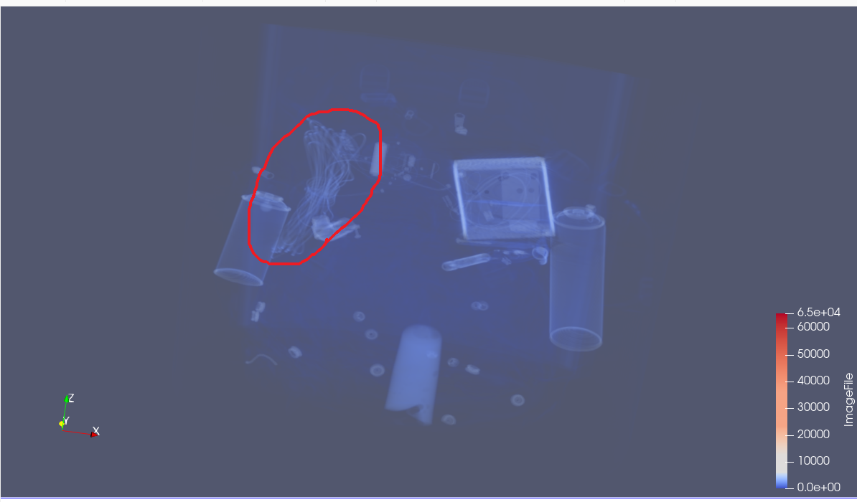

Too thin to be a charging line, I guess he must be a good plumber.

1. A faucet

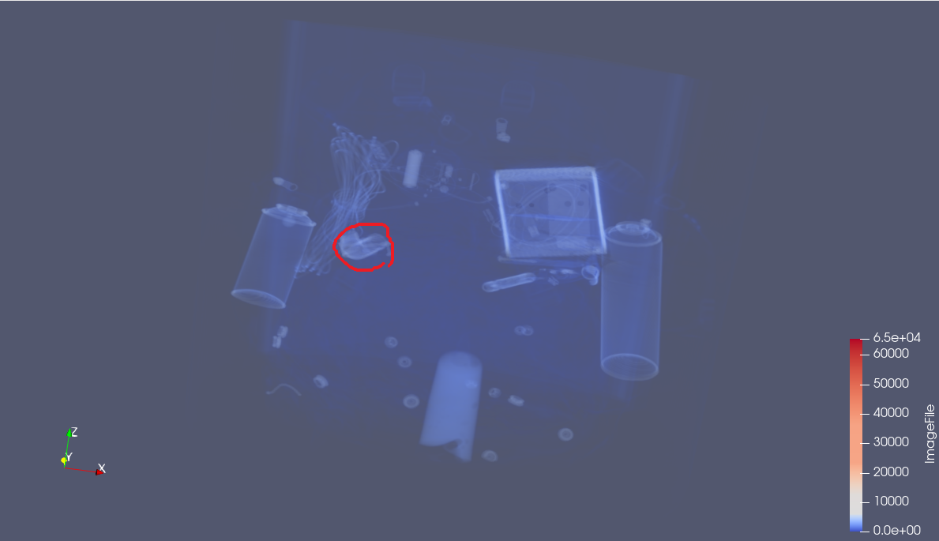

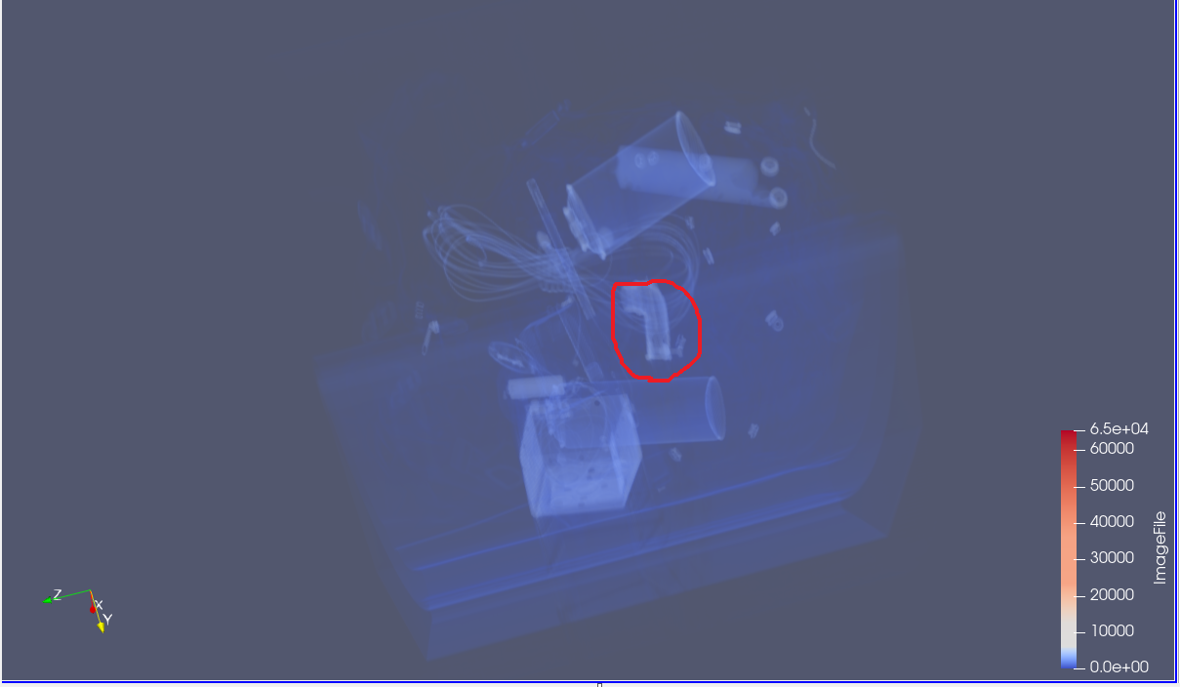

Beside the smoke grenade and the copper wire.

Plumber confirmed.

1. An ointment

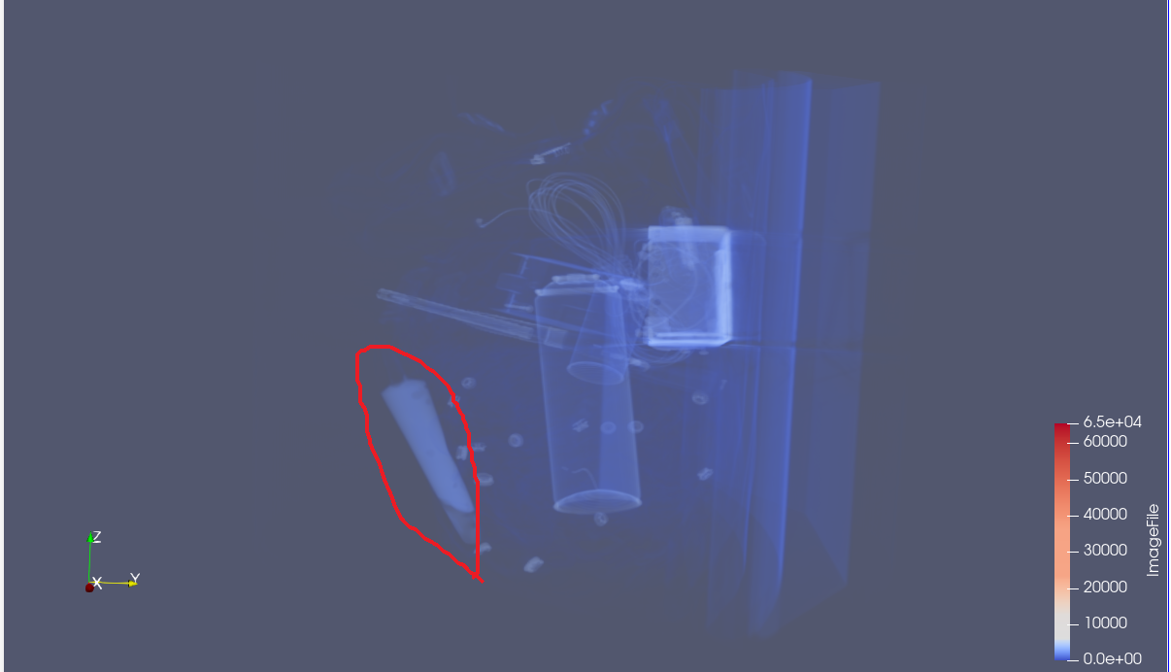

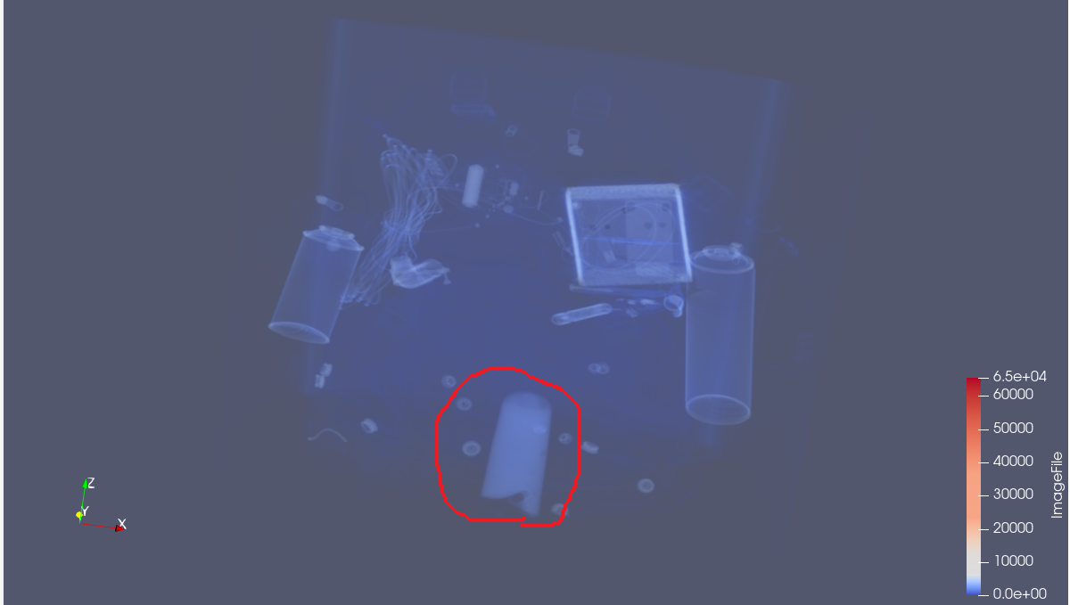

Far from other stuffs, with something filled, and its shape looks like some cosmetics.

Beauty and health are important.

1. A watercolor pen

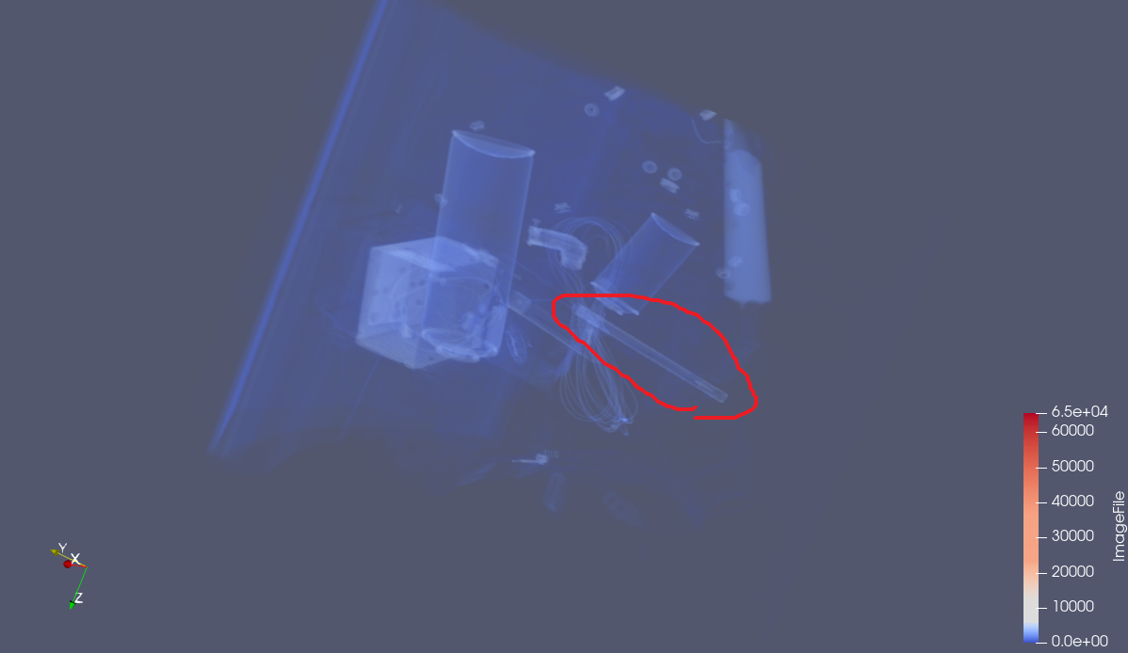 

Looks like a drawing tool, with a brush on its head, must use for painting.

1. A cheese

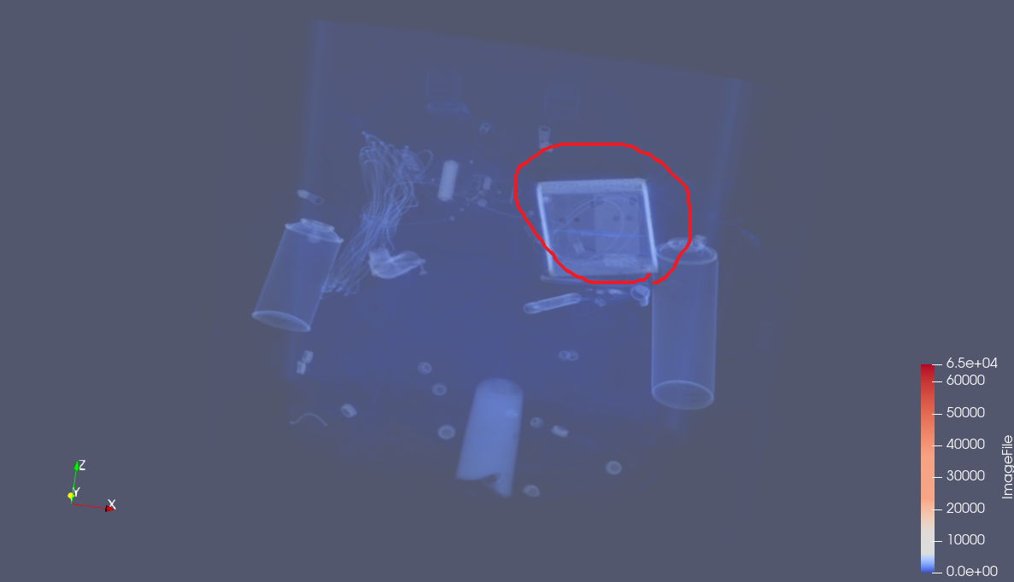

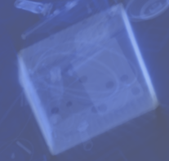

A cuboid with holes on it, and a mark for its price… I can’t figure out what is this except for a cheese…